Tailored Application Access for Enhanced User Experience

1.Project Overview:

The "Tailored Application Access" project aims to enhance user experience and efficiency within ServiceNow by providing personalized and seamless access. Leveraging advanced user-centric design principles, adaptive technologies, and intelligent access control mechanisms, this initiative will streamline application interactions, improve operational efficiency, and ensure robust data security, ultimately empowering users and aligning with ServiceNow's long-term objectives.

2.Objectives:

Primary Objectives:

1. Enhance User Experience: Provide personalized and seamless access to ServiceNow applications.

2. Improve Operational Efficiency: Streamline application interactions and reduce complexity.

3. Ensure Robust Data Security: Implement intelligent access control mechanisms to protect sensitive data.

Secondary Objectives:

1. Empower Users: Provide tailored access to increase user autonomy and productivity.

2. Simplify Application Interactions: Reduce navigation complexity and improve overall usability.

3. Leverage Advanced Technologies: Utilize user-centric design principles, adaptive technologies, and intelligent access control mechanisms.

4. Align with Long-term Goals: Support ServiceNow's strategic objectives for user empowerment and streamlined application interactions.

Key Performance Indicators (KPIs):

1. User satisfaction ratings

2. Application interaction time reduction

3. Security incident reduction

4. User adoption and engagement increase

5. Operational efficiency metrics (e.g., reduced support requests)

3.Detailed steps to solution design:

Activity 1: Create a Table

I logged into my ServiceNow Developer Instance and navigated to System Definition > Tables. There, I created a new custom table titled "Service Request" with two fields:

1. Name (String)

2. Issue (String)

I then submitted the new table configuration.

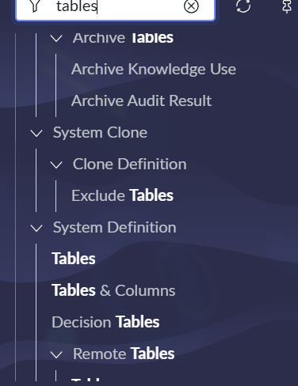

Activity 2: Create Users

In ServiceNow, I went to System Security > Users and created a new user account. I completed the necessary fields, including username, password, email, and other relevant information, and then submitted the form

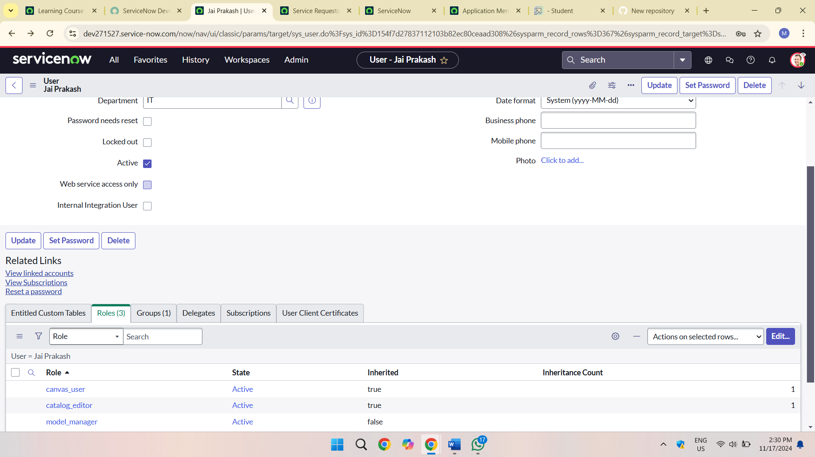

Activity 3: Create Groups

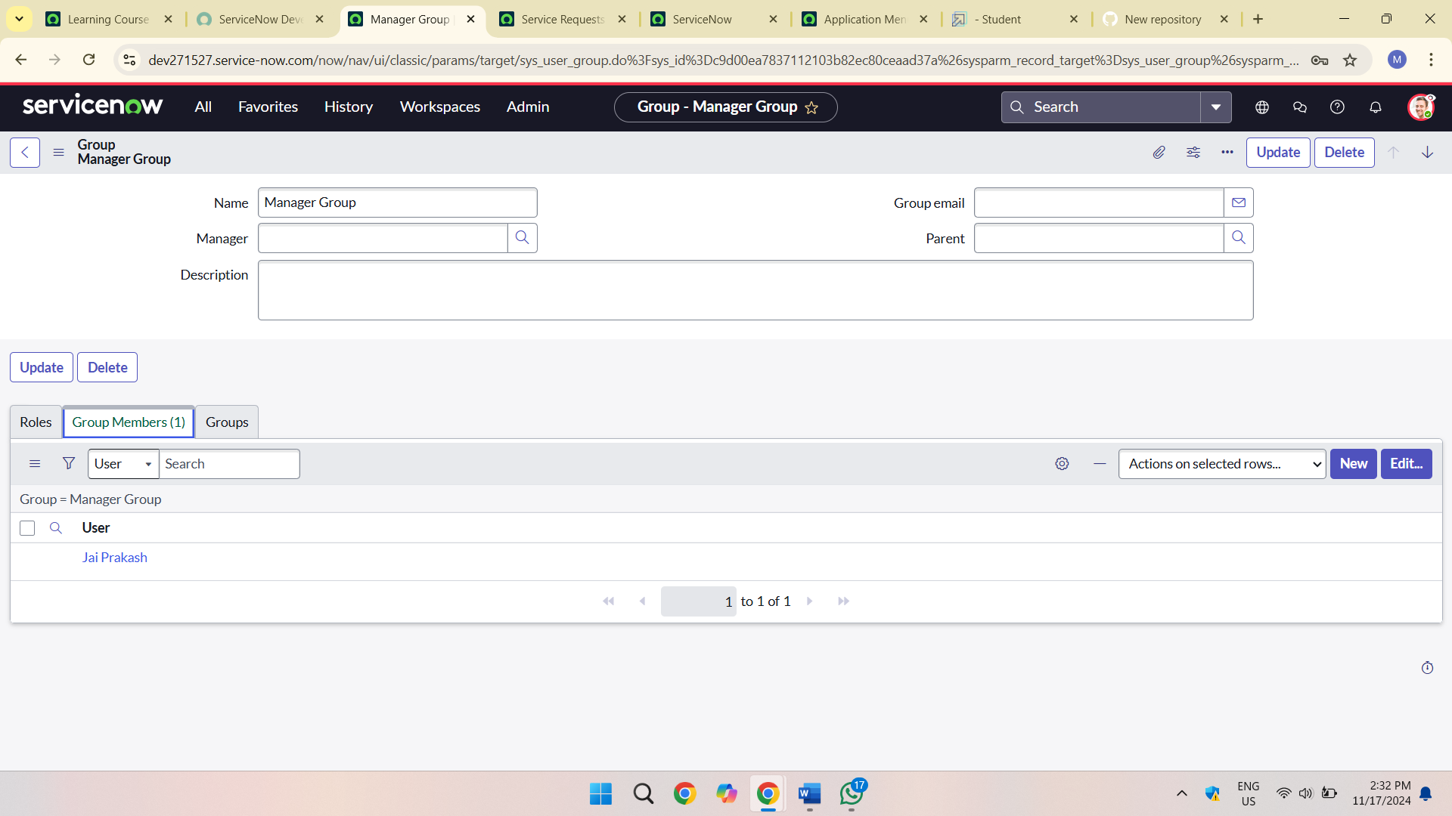

I performed the following steps:

1. Accessed System Security > Groups.

2. Created a new group.

3. Added Jai Prakash as a member and assigned Manager role.

4. Saved the changes.

Activity 4: Create Roles

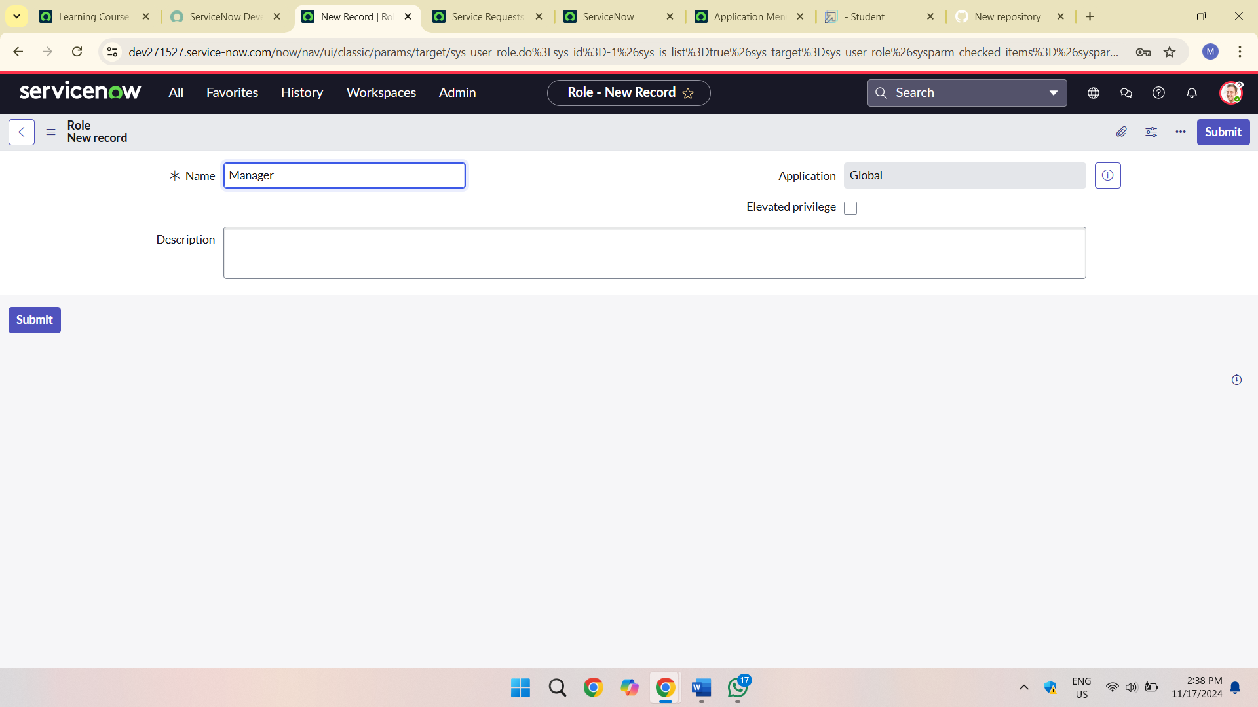

Under System Security > Roles, I established a new role in ServiceNow and subsequently assigned it to Jai Prakash's user profile.

Activity 3: Created Modules

I customized the Service Request menu in Application Menus, adding 'Create New' and 'All' modules with role-based visibility.

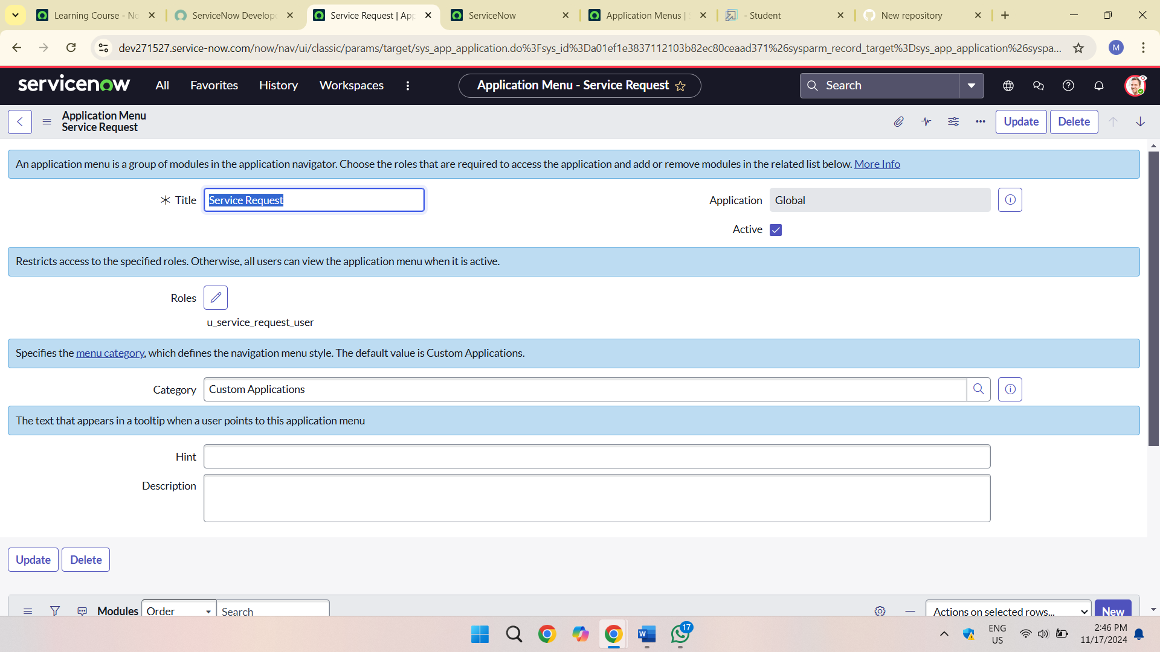

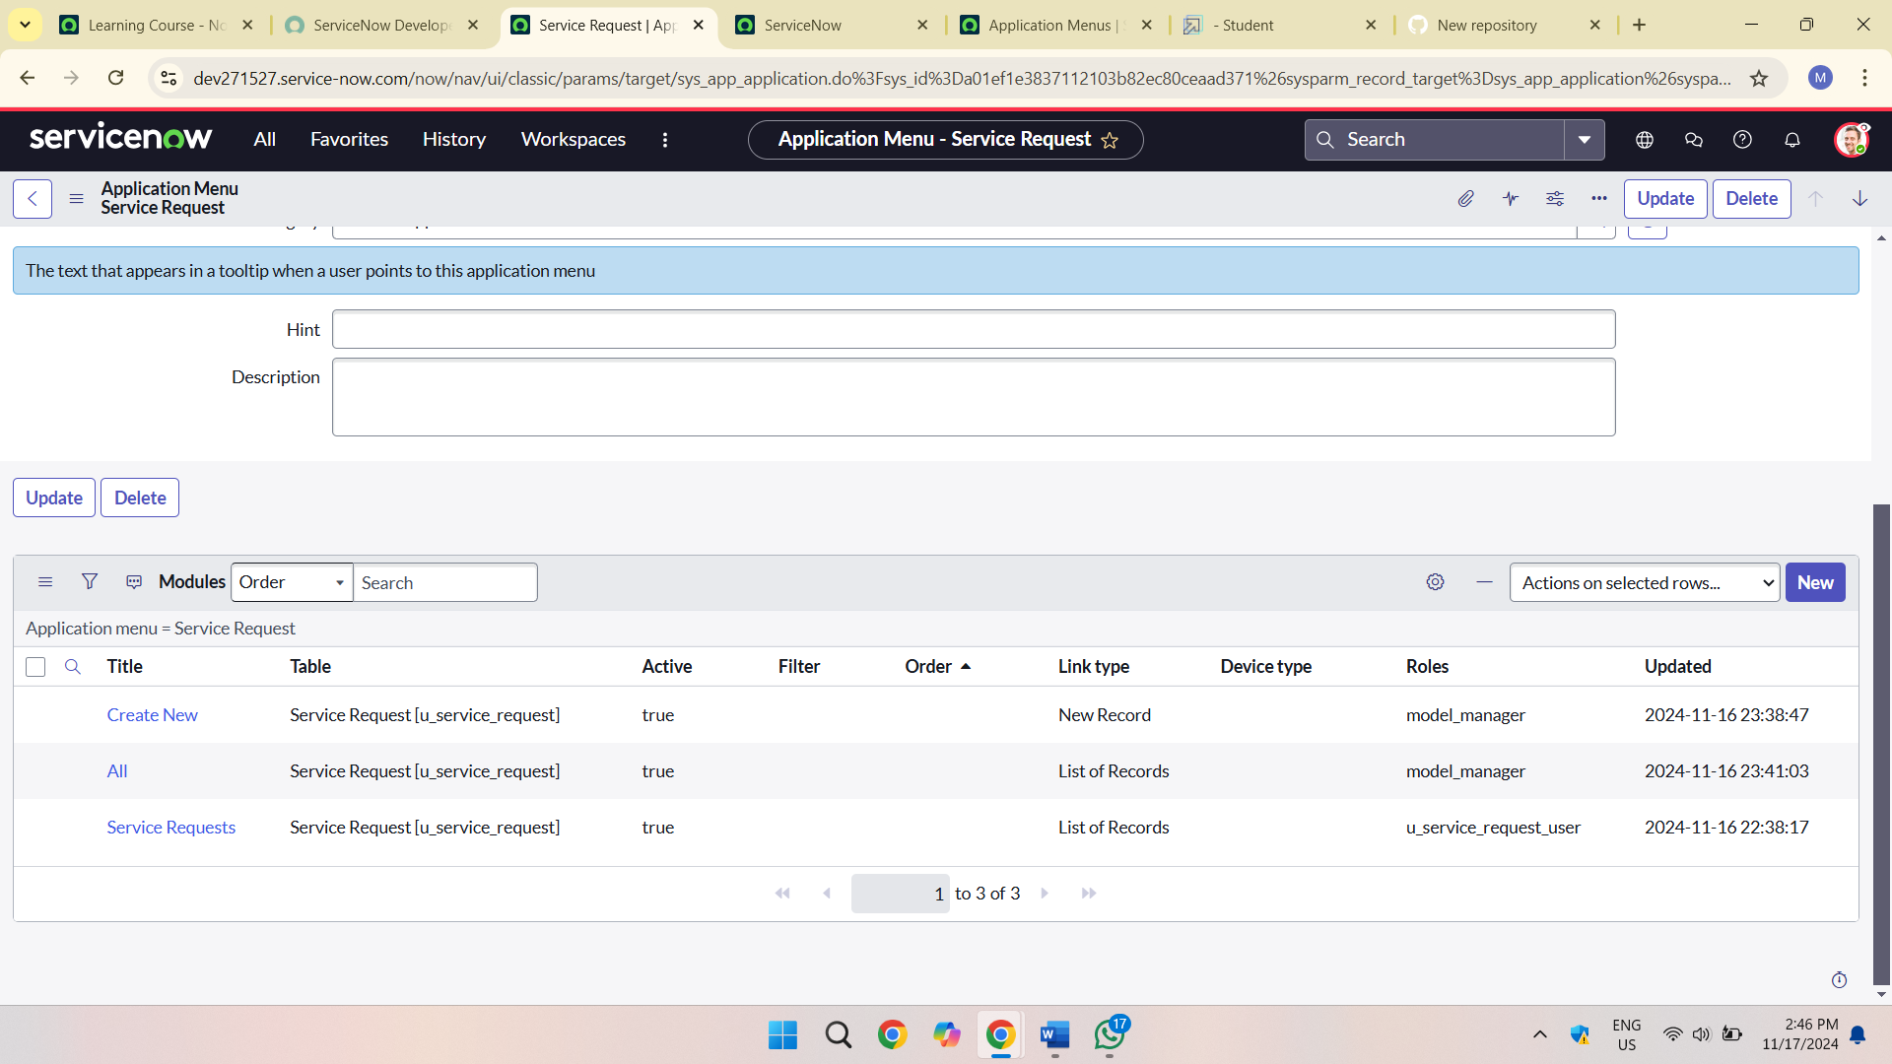

Activity 5: Testing and Validation

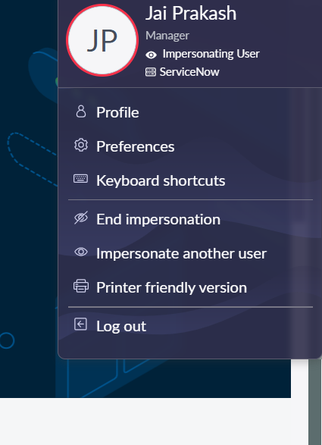

To test user permissions, I navigated to the Profile section and initiated impersonation of the user I created. Then, I searched for 'Service Request' under 'All' and accessed the application, confirming the visibility of 'Create New' and 'All' modules.

5. Key Scenarios Addressed by ServiceNow in the implementation Project

Key Challenges:

- Generic ServiceNow setup for all users

- Role-irrelevant applications and modules caused confusion

- Inefficiencies across department

Implementation Solution:

- Role-specific applications and modules

- Personalized ServiceNow experience

- Enhanced efficiency and productivity

7.Conclusion:

Here are a few revised versions:

Version 1: Concise

Conclusion:

This ServiceNow implementation project successfully addressed key objectives, including:

1. Table creation: "Service Request" with relevant columns.

2. User management: User creation, role assignment, and group configuration.

3. Access control: Custom role definition and assignment.

4. Application development: "Create New" and "All" modules with role-based visibility.

5. Testing and verification: Utilizing impersonation to confirm user access.